**Pizza sales sql queries**

**KPI’s**

1. **Total Revenue :**

select sum(total_price) as Total_Revenue from pizza_sales;

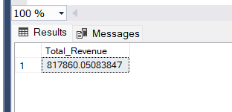

1. **Average Order Value**

select sum(total_price)/count(distinct order_id) as Average_Order_value from pizza_sales;

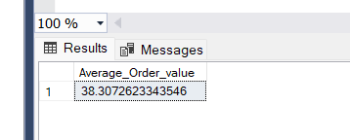

1. **Total Pizzas sold**

select sum(quantity) as Toatl_pizzas_sold from pizza_sales;

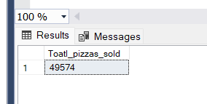

1. **Total Orders placed**

select count(distinct order_id) as Total_orders from pizza_sales;

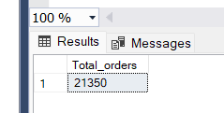

1. **Average pizzas per order**

select cast(cast(sum(quantity) as decimal(10,2))/ cast(count(distinct order_id) as decimal(10,2)) as decimal(10,2)) as Average_Pizzas_per_order from pizza_sales;

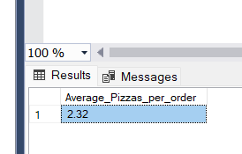

1. **Daily Trend for Total Orders**

select datename(dw,order_date) as Order_day, count(distinct order_id) as Total_orders

from pizza_sales

group by datename(dw,order_date);

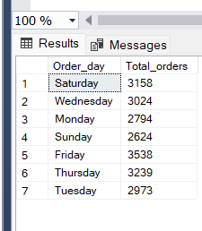

1. **Monthly trend for orders**

select month(order_date) as Month_name,count(distinct(order_id)) as Total_orders from pizza_sales

group by month(order_date)

order by month(order_date) asc;

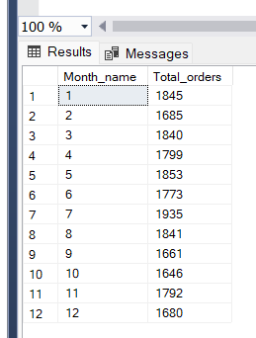

or

select datename(month,order_date) as Month_name, count(distinct(order_id)) as Total_orders from pizza_sales

group by datename(month,order_date)

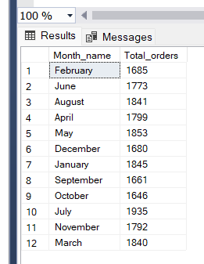

1. Hourly trend for orders:

select datename(hour,order_time) as Order_day, count(distinct order_id) as Total_orders

from pizza_sales

group by datename(hour,order_time)

order by datename(hour,order_time);

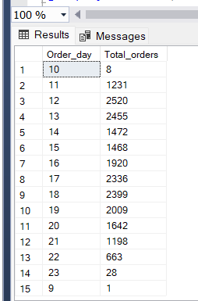

1. Percentage of sales by pizza category

select pizza_category,sum(total_price) as Total_price, sum(total_price)*100/(select sum(total_price) from pizza_sales) as percentage_of_sales

from pizza_sales

group by pizza_category;

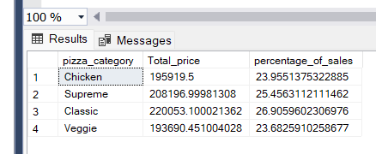

1. Percentage of sales by pizza size (for 1st quarter)

select pizza_size,sum(total_price) as Total_price,cast( sum(total_price)*100/(select sum(total_price) from pizza_sales where datepart(quarter,order_date)=1) as decimal(10,2))as percentage_of_sales

from pizza_sales

where datepart(quarter,order_date)=1

group by pizza_size

order by percentage_of_sales desc;

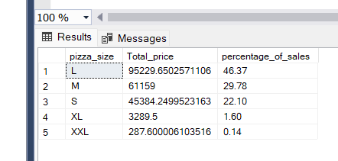

1. Top 5 pizaa by revenue

select top 5 pizza_name,sum(total_price) as Total_Revenue from pizza_sales

group by pizza_name

order by Total_Revenue desc;

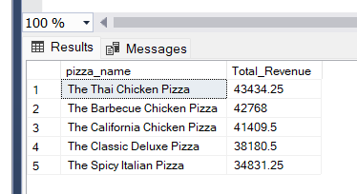

1. Bottom 5 pizza by revenue

select top 5 pizza_name,sum(total_price) as Total_Revenue from pizza_sales

group by pizza_name

order by Total_Revenue asc;

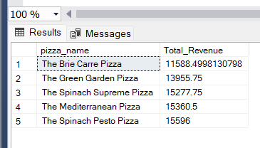

1. Top 5 pizzas by quantity

select top 5 pizza_name,sum(quantity) as Total_quantity from pizza_sales

group by pizza_name

order by Total_quantity desc;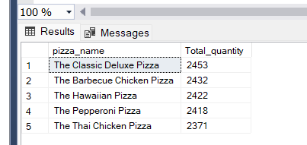

1. Bottom 5 pizzas by quantity

select top 5 pizza_name,sum(quantity) as Total_quantity from pizza_sales

group by pizza_name

order by Total_quantity asc;

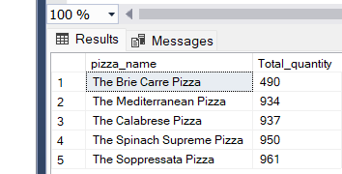

1. Top 5 pizzas by orders

select top 5 pizza_name,count(distinct(order_id)) as Total_Orders from pizza_sales

group by pizza_name

order by Total_Orders desc;

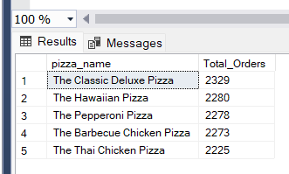

1. Bottom 5 pizzas by order

select top 5 pizza_name,count(distinct(order_id)) as Total_Orders from pizza_sales

group by pizza_name

order by Total_Orders asc;

